An obstinate case of Autism treated with bird remedy.

A mother consulted me for her 2 and half year’s son. He was a diagnosed case of Autism and ADHD.

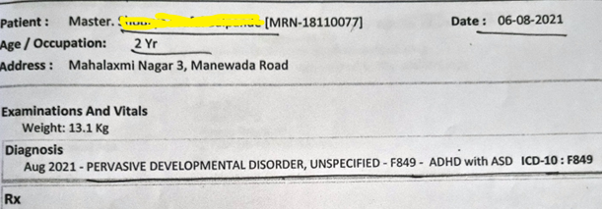

Mother said-

He born 3-4 weeks early. Premature. I suffered from bleeding hence LSCS was performed. His birth weight was 3 kgs. Pediatrician said his development will be sluggish. I couldn’t breast fed him due to lack of milk. Dentition and walking was normal for the age. He has speech issues, can utter the word papa but doesn’t understand the relation. For him ‘papa’ is just a word. He doesn’t call me mom, points finger to an object if he wants it but couldn’t speak. Till the age of 18 months, he was able to talk, gradually lost his speech.

When he was 2 & 1/2 years old, relatives told me that he is not responding well, I thought he is deaf. If we call him by his name, Shaurya, he doesn’t respond. If I ask something interested to him, he answers, for ex. Sonu, do you want chocolate? He says yes. Once there was thunderstorm but he was absolutely fine and laughing. No fear at all. He doesn’t understand the risk factor. He is restless, cannot sit at one place and does not sleep. Jumps 1000-2000 times/day

He jumps in bed for hours! He wants us to watch and clap/ cheer for him. Wants open places. Hurts people by throwing things. He is comfortable only with gents not with ladies. Doesn’t respond if we call him. Cannot express if needs anything, cannot talk about pee, if I ask him, he says yes but will never tell by himself. Passes stool in panty, cannot unbutton the pant.

He becomes destructive if things go against his wish, tears paper. He broke TV set.

If his sister comes to me, he bites her.

He feels that – Its ONLY MY mother!

Sleep Restless! Constant moving in bed. He sucks thumb as soon as sees blanket. Sometimes put blanket on his sister’s body and sleeps on that.

He is irritable. Banging head on floor at any contradiction, crying for hours, likes spicy food. Loves to play in water even watering the plants in garden.

Stool occasionally hard.

Excessive Thirst. He may drink small or large quantity, drinks even during sleep.

His Vertex and forehead sweats a lot. His neck wet when he wakes up.

**Family history-**

Elder sister- Normal

Father- Introverted, talking to himself, lack of confidence

**H/o mother during pregnancy**

She said – My first daughter was a big trouble hence I was not ready for the second child. Family wanted it badly; they compelled me to be pregnant. It was like Dracula sitting on my neck all the time; ultimately, I surrendered and kept pregnancy. For me it was like a blind jump in a well. I feel to give birth is not enough. Anybody can do this but to raise child well is important. We should physically and mentally fit for this. I was diagnosed with thyroids during this pregnancy and I tented to do absurd things like I watched the ghost movies, porn movies and sex videos. Never did this before.

I was disappointed with the birth of son. I wanted a daughter. I hate boys. I feel boys are not good. After marriage, when I came to know about my husband’s bizarre behavior, his real age and real job which they hid from us, I felt hurt, betrayed. It was shameful.

During pregnancy, I was not happy not sad, just neutral.

**Rubrics considered-**

MIND - SPEECH - inarticulate

MIND - TACITURN - mutism - children; in

MIND - FEARLESS

MIND - JUMPING - children; in

MIND - FLATTERED - desire to be

MIND - EXPRESSING oneself - cannot express oneself

MIND - ANGER - contradiction; from

MIND - POSSESSIVENESS

MIND - IRRITABILITY - contradiction; from - slightest; at

MIND - WATER - loves

MIND - JUMPING - impulse to jump

HEAD - PERSPIRATION of scalp

NECK - PERSPIRATION

STOMACH - THIRST - extreme

STOOL - HARD

SLEEP - RESTLESS - bodily restlessness, from

GENERALS - FOOD and DRINKS - spices - desire

GENERALS - ENERGY - excess of energy - children; in

Many remedies like Sulphur, Phosphorus,Agaricus,Tarentul his.,Ignatia,Sepia, Lycopodium,Stramonium etc came up.

None of the above remedy covered gross rubrics. In such condition, we usually put nosode but there was no history of toxin exposure during pregnancy, hence ruled out.

**Analysis and evaluation-**

During interview, I understood that I am talking to a disappointed woman who bare this child against her Will. She could not accept the child (as a boy) even after delivery. But today, she came to meet me with her autistic child with a ray of hope.

My need was a remedy which should cover child’s present complaints and mother’s symptoms before and during pregnancy.

**Prescription**

Falcon peregrinus 1M one dose.

**Comments on selection of remedy**

Falcon stood on 50th number in my repertorization chart.

When I applied the filter ‘ Graphical results by strategy’ in radar software, Falcon came up along with Anacardium and Aurum met, in small remedies. Usually polychrest remedies cover many symptoms in each patient as they have multiple symptom bank. Small remedies cover those symptoms, which are the unique symptoms of the individual. I chose Falcon as it was the most suitable match to mother’s and child’s symptoms.

A long experience with autistic cases, taught me that while dealing autism, we must see the reflection of mother in child and vice versa.

Mother’s symptoms-

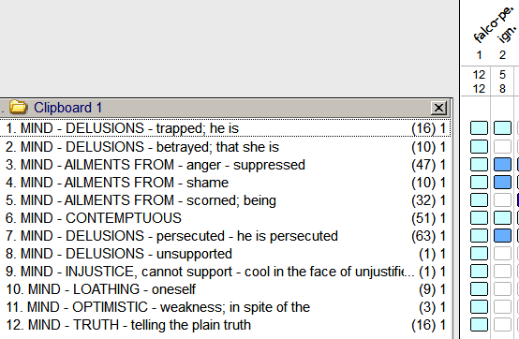

Child’s symptoms-

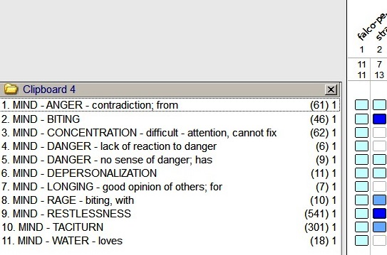

Peregrine Falcons are courageous, strong and extremely agile birds.

‘There needs to be more freshness and more air and space around.’

***Follow up after 8 days-***

Mother said, we took him to a doctor yesterday night as he was shouting, crying, injuring himself. We couldn’t hold him. He caught fever since Saturday for that we gave him allopathic medicine.

**Prescription**

Falcon peregrinus 1M one aqua dose as parents broke the action of remedy with other medication.

***Follow up after one month –***

Mother said, he learnt new words and making sentence. He used to call ‘natat’ to ‘light’ but now using meaningful word, keeping shoes at proper place and unwashed clothes in laundry bag.

Me-Could you give me example about his sentence making?

He makes two-words sentence like ‘you eat’…I eat . I drink...etc

**Prescription**

Placebo.

***Follow up after 3 months-***

Mother said- Now he is saying ‘No’ to the things which he is not willing to do, making three words sentence like -I am going out.

He is composing sentence, recognizing things and his speech is clear.

**Prescription**

Placebo.

***Follow up after six months-***

Mother said- he still playing in water, if I try to pull him out, he relaxes his body (becomes loose) and then throws out the things.

He wants to plant water 10-15 times so that he can stay in water.

Me-Did your doctor anytime tell you that you have inadequate water in uterus during pregnancy?

No.

Sonu born with L.S.C.S . It was breech presentation

Me.-when he born, was his neck surrounded by umbilical cord?

Yes.

(I wanted to confirm about oligohydramnios as the remedy Amniotic fluid struck my mind)

**Prescription**

Falcon peregrinus 1M one aqua dose given.

His Cars test done, showing following results.

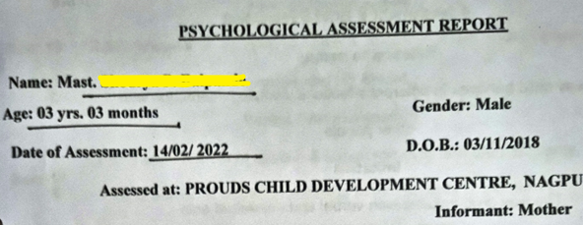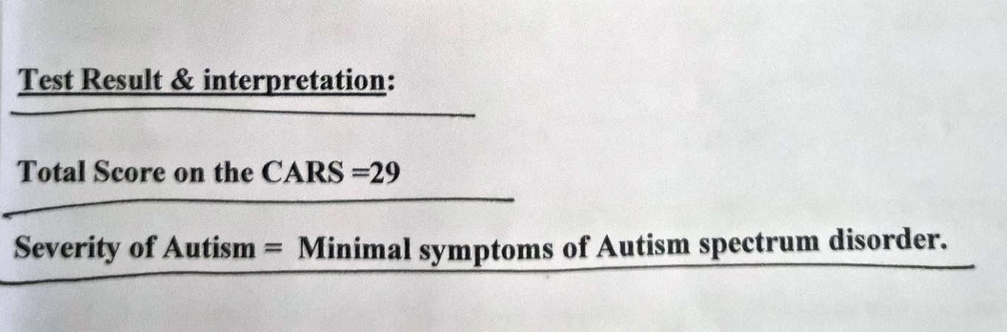

***Follow up after 8 months-***

Mother said- last month, we his CARS test done, he answered all questions and sat for half an hour at one place.

The therapist said ,he is the first patient who sat for such a long-time during test.

I didn’t tell him that we are on homeopathic treatment.

Me.-Why?

Mo.-Just…didn’t tell him

Me.-You should tell him that you are on homeopathic treatment for six months

Mo.-Ok. I will.

Father said-Now a days, he understands if we discuss anything. He puts his input, for ex. we did not want to visit his cousin, I told my daughter that she is out of town, he interrupted and said that shrau didi (cousin) is not at home.

How much improvement did you observe after homeopathic medicine?

Around 50%

Me- we started treatment at 16th august 2021 and today is 15th March 2022,almost seven months. How much improvement you feel now?

He is not so matured yet. He is speaking well, his vocabulary improved, he understands everything!

He listens and follow the commands.

Me to mother- you just went for his CARS test…what is the report?

His Autism level is none to minimal, means even less than mild!

Me- He has ADHD too, hence hyperactive. Autism is nill now.

Mo.-Yes autism is nill now. His therapist said the same.

**Prescription**

Falcon peregrinus 10 M one aqua dose given to speed up the recovery.

***Follow up after 9 months-***

Mother said- He can speak everything even complex sentence too with crystal clear speech. He is going to school. Sitting there for 2 hours in continuity which he previously never did. He is comfortable with female teachers and learnt 3 poems in these 10 days.

Teacher said , he catches tune first and then words.

Now he is strong in using CLEAR words.

He throws things but as a play not to injure anyone, no biting, no spitting.

**Prescription**

Placebo.

***Follow up after 10 months-***

Mother said-His head banging increased, shakes his neck in a strange way, spitting badly.

Dr- From how long it increased?

Mo.- I was thinking what happened suddenly, the therapist also asked the same. It began after taking polio shot.

He is obstinate and crying a lot! Rolling on floor if contraindicated.

If I do not listen him, he cries, bites and banging head, injuring others.

Dr.-Are you sure polio shot given in last week is responsible for this?

Mo.-YES!

**Prescription**

Carcinosin 200 one dose.

I considered the below rubrics-

GENERALS - VACCINATION; ailments after - children; in

carc.

GENERALS - VACCINATION; ailments after - reaction; severe

carc.

Polio shot disturbed him on mental plane. Emotional turmoil was the outcome.

***Follow up after 11 months-***

Mother said- he is calm and quite now. No temper tantrums.

Me- we started his medication 10 months back. In the beginning, you complained something about his hairs. What was that?

Mo.-His hairs were like plastic, used to feel artificial and shining.

Now they are 90% better.

Me- How do you feel when you touch his hairs?

They are soft now and normal now.

His speech is excellent, talking well, wants good and tasty food, asking for pickles, papad, fried chilly…

He has good sense of taste!

**Prescription**

Placebo.

His recent Communication DEALL developmental checklist confirmed a lot progress.

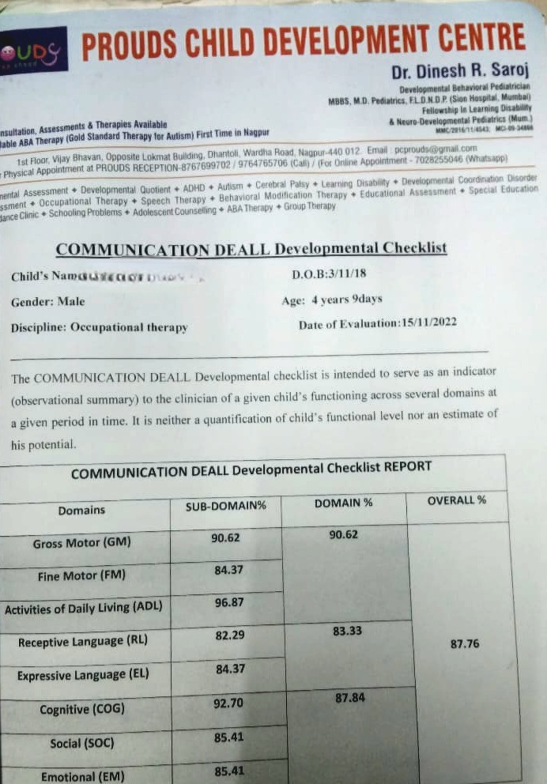

**Take away-**

Patient is still under my medication. I just prescribe for acutes.

It is important to know where to stop.

Don’t forget, homeopathic medicines can create the disorders which they are efficient to cure!

Dr. Kavita Chandak

India

[drkavitachandak@gmail.com](mailto:drkavitachandak@gmail.com)

[www.drkavitachandak.com](http://www.drkavitachandak.com)